Student Name | G. Manasa
Student Registration Number | 241U1R3007 | Class &Section: DS-IIA
Study Level: UG/PG | UG | Year &Term: II & I
Subject Name | Digital Electronics

Name of the Assessment | Lab Report
Date of Submission | 24/08/2025

LAB REPORT-7

Simulation of 8*1MUX, 1*4 DeMUX, 8*3 Encode and 3*8 Decoder

Implementation of 8×1 Multiplexer using SimulIDE
1.Aim
To design and simulate an 8×1 Multiplexer (MUX) using basic logic gates (AND, OR, NOT), Fixed Voltage, GND, toggles, and probes in SimulIDE.
2.Apparatus Required
- SimulIDE software
- Logic gates: AND, OR, NOT
- Fixed Voltage source (+5 V)
- GND source
- Toggle switches (for inputs & select lines)
- Logic probes / LEDs (for outputs)
3. Theory
A multiplexer is a combinational circuit that selects one input line out of multiple input lines and routes it to a single output line, based on select signals.
- An 8×1 MUX has:
  - 8 data inputs (D0–D7)
  - 3 select inputs (S2, S1, S0)
  - 1 output (Y)
Function: Depending on the binary value of select inputs, one of the 8 data inputs is connected to the output.
Expression:
Y = Σ(Di · mi) for i = 0 to 7
Where mi = minterm of select inputs corresponding to selection of Di.
Minterms:
- m0 = S2'·S1'·S0' → Y = D0·m0
- m1 = S2'·S1'·S0 → Y = D1·m1
- m2 = S2'·S1 ·S0' → Y = D2·m2
- m3 = S2'·S1 ·S0 → Y = D3·m3
- m4 = S2 ·S1'·S0' → Y = D4·m4
- m5 = S2 ·S1'·S0 → Y = D5·m5
- m6 = S2 ·S1 ·S0' → Y = D6·m6
- m7 = S2 ·S1 ·S0 → Y = D7·m7
Final expression:
Y = D0·S2'·S1'·S0' + D1·S2'·S1'·S0 + D2·S2'·S1·S0' + D3·S2'·S1·S0
+ D4·S2·S1'·S0' + D5·S2·S1'·S0 + D6·S2·S1·S0' + D7·S2·S1·S0

4.Truth Table
S2 | S1 | S0 | Selected Input | Output (Y)
0 | 0 | 0 | D0 | D0
0 | 0 | 1 | D1 | D1
0 | 1 | 0 | D2 | D2
0 | 1 | 1 | D3 | D3
1 | 0 | 0 | D4 | D4
1 | 0 | 1 | D5 | D5
1 | 1 | 0 | D6 | D6
1 | 1 | 1 | D7 | D7

5. Procedure in SimulIDE
- Open SimulIDE and create a new project.
- Place 8 toggle switches for data inputs (D0–D7).
- Place 3 toggle switches for select inputs (S2, S1, S0).
- Add NOT gates to generate complements of select inputs (S2', S1', S0').
- For each Di:
  - Form minterm using 2-input AND gates (cascade where necessary).
  - AND Di with its respective minterm.
- Combine all eight product terms using an OR tree.
- Connect the final OR output to a logic probe/LED as Y.
- Run the simulation and verify operation.

6.Circuit Diagram:
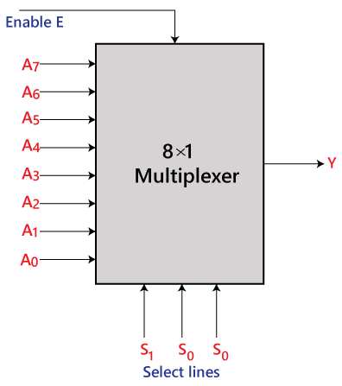
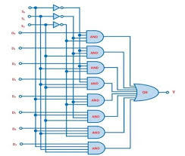
7. Result
The 8×1 Multiplexer was successfully designed and simulated using basic logic gates in SimulIDE. The truth table and observed output match the expected results.

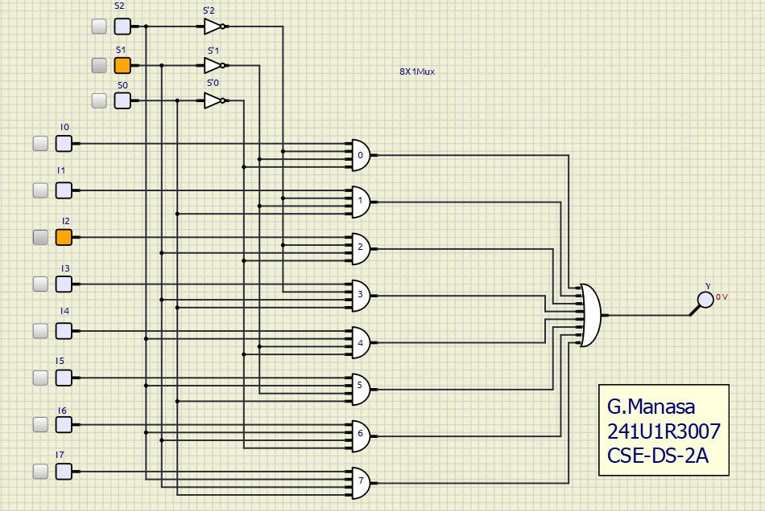

Implementation of 1×4 Demultiplexer using SimulIDE
1.Aim
To design and simulate a 1×4 Demultiplexer (DEMUX) using basic logic gates (AND, NOT), Fixed Voltage, GND, toggles, and probes in SimulIDE.
2. Apparatus Required
- SimulIDE software
- Logic gates: AND, NOT
- Fixed Voltage source (+5 V)
- GND source
- Toggle switches (for input and select lines)
- Logic probes / LEDs (for outputs)
3. Theory
A demultiplexer (DEMUX) is a combinational circuit that takes a single input and distributes it to one of several outputs based on the select lines.
- A 1×4 DEMUX has:
  - 1 data input (D)
  - 2 select inputs (S1, S0)
  - 4 outputs (Y0–Y3)
Function: Depending on the binary value of select inputs, the single data input is routed to one of the 4 outputs.
Expressions:
- Y0 = D·S1'·S0'
- Y1 = D·S1'·S0
- Y2 = D·S1 ·S0'
- Y3 = D·S1 ·S0
4.Truth Table
S1 | S0 | Input D | Y0 | Y1 | Y2 | Y3
0 | 0 | 0 | 0 | 0 | 0 | 0
0 | 0 | 1 | 1 | 0 | 0 | 0
0 | 1 | 1 | 0 | 1 | 0 | 0
1 | 0 | 1 | 0 | 0 | 1 | 0
1 | 1 | 1 | 0 | 0 | 0 | 1
5. Procedure in SimulIDE
- Open SimulIDE and create a new project.
- Place one toggle switch for the data input (D).
- Place two toggle switches for the select inputs (S1, S0).
- Add NOT gates to generate complements S1' and S0'.
- Use AND gates to implement each output:
  - Y0 = D·S1'·S0'
  - Y1 = D·S1'·S0
  - Y2 = D·S1 ·S0'
  - Y3 = D·S1 ·S0
- Connect the outputs to probes/LEDs.
- Run the simulation and toggle the select inputs to verify operation.
6.Circuit Diagram:
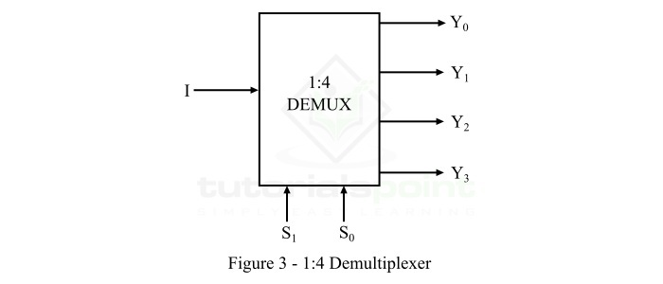
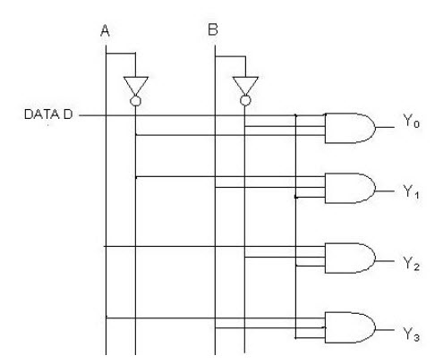

7.Result
The 1×4 Demultiplexer was successfully designed and simulated using basic logic gates in SimulIDE. The truth table and observed output match the expected results.

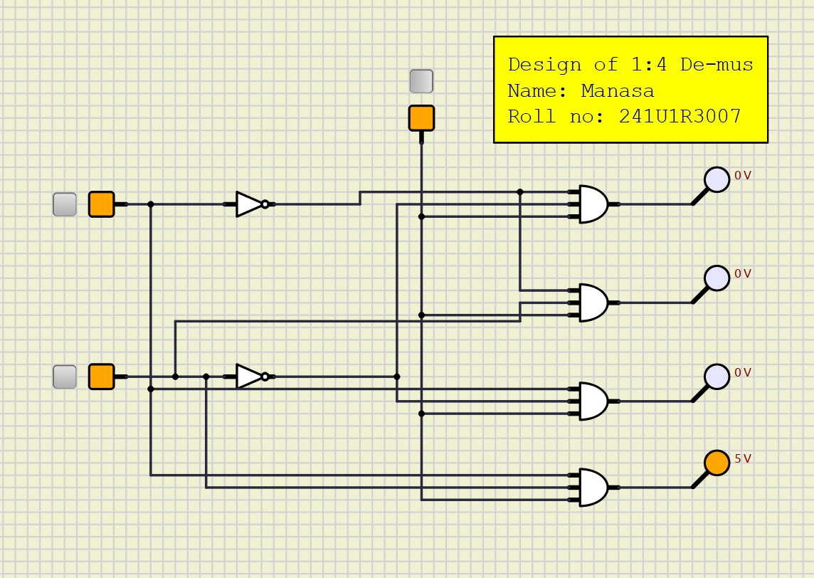

Implementation of 8×3 Encoder using SimulIDE
1. Aim
To design and simulate an 8×3 Encoder using basic logic gates (OR), Fixed Voltage, GND, toggles, and probes in SimulIDE.
2. Apparatus Required
- SimulIDE software
- Logic gates: OR
- Fixed Voltage source (+5 V)
- GND source
- Toggle switches (for 8 input lines)
- Logic probes / LEDs (for 3-bit output)
3. Theory
An Encoder is a combinational circuit that converts 2^n input lines into an n-bit binary output.
- An 8×3 Encoder has:
  - 8 input lines (D0–D7)
  - 3 output lines (Y2, Y1, Y0)
Function: When any one of the 8 inputs is high, the encoder generates the corresponding 3-bit binary code at the output.
Equations:
- Y0 = D1 + D3 + D5 + D7
- Y1 = D2 + D3 + D6 + D7
- Y2 = D4 + D5 + D6 + D7
4.Truth Table
Input Line | Y2 | Y1 | Y0
D0 = 1 | 0 | 0 | 0
D1 = 1 | 0 | 0 | 1
D2 = 1 | 0 | 1 | 0
D3 = 1 | 0 | 1 | 1
D4 = 1 | 1 | 0 | 0
D5 = 1 | 1 | 0 | 1
D6 = 1 | 1 | 1 | 0
D7 = 1 | 1 | 1 | 1
(Only one input should be high at a time)
5. Procedure in SimulIDE
- Open SimulIDE and create a new project.
- Place eight toggle switches for the inputs D0–D7.
- Place three output probes/LEDs for Y2, Y1, Y0.
- Connect the input lines to the OR-gate structures:
  - Y0 = D1 + D3 + D5 + D7
  - Y1 = D2 + D3 + D6 + D7
  - Y2 = D4 + D5 + D6 + D7
- Run the simulation and toggle one input at a time to verify outputs.

6.Circuit Diagram:
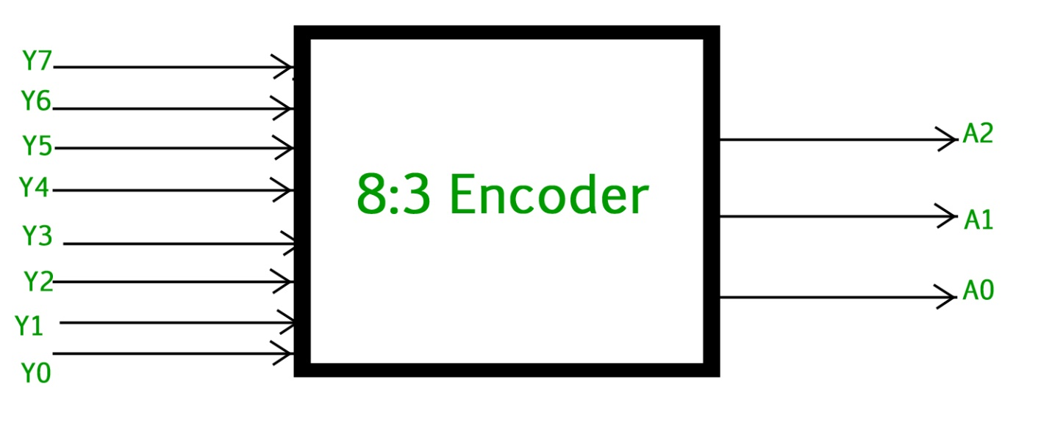
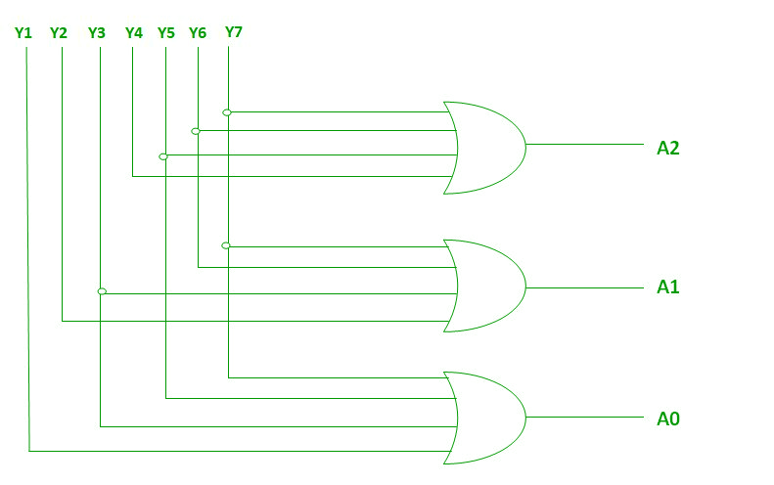
7. Result
The 8×3 Encoder was successfully designed and simulated in SimulIDE using only OR gates. The observed output matched the expected binary code.
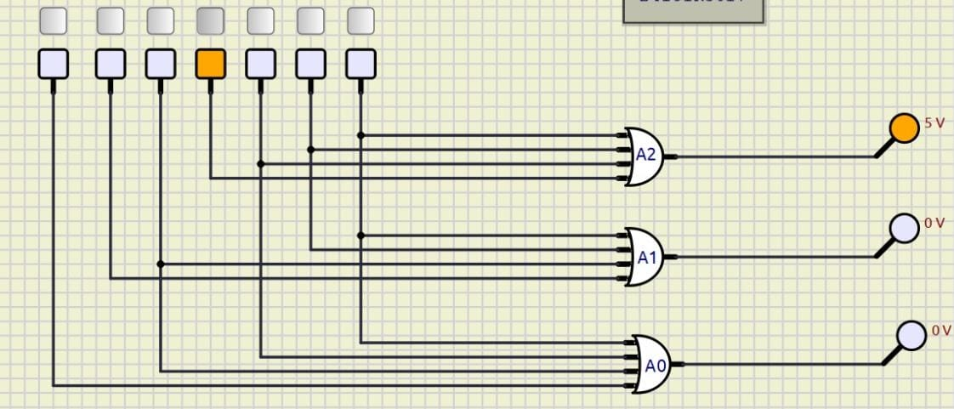

Implementation of 3×8 Decoder using SimulIDE
1. Aim
To design and simulate a 3×8 Decoder using basic logic gates (AND, NOT), fixed voltage, GND, toggles, and probes in SimulIDE.
2. Apparatus Required
- SimulIDE software
- Logic gates: AND, NOT
- Fixed Voltage source (+5 V)
- GND source
- Toggle switches (for 3 input lines A, B, C)
- Logic probes / LEDs (for 8 outputs D0–D7)
3. Theory
A Decoder is a combinational circuit that converts n-bit binary input into 2^n unique outputs.
- A 3×8 Decoder has:
  - 3 input lines (A, B, C)
  - 8 output lines (D0–D7)
Function: For every binary input combination, one and only one output becomes high.
Equations:
- D0 = A' · B' · C'
- D1 = A' · B' · C
- D2 = A' · B · C'
- D3 = A' · B · C
- D4 = A · B' · C'
- D5 = A · B' · C
- D6 = A · B · C'
- D7 = A · B · C

4. Truth Table
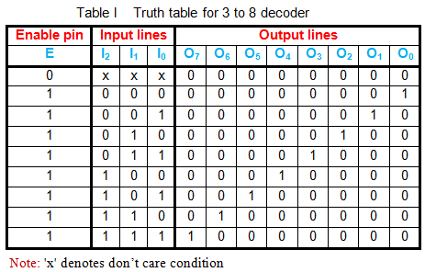

5. Procedure in SimulIDE
- Open SimulIDE and create a new project.
- Place three toggle switches for inputs A, B, C.
- Place NOT gates to generate complements A', B', C'.
- Place eight AND gates for outputs D0–D7.
  - D0 = A'·B'·C'
  - D1 = A'·B'·C
  - D2 = A'·B·C'
  - D3 = A'·B·C
  - D4 = A·B'·C'
  - D5 = A·B'·C
  - D6 = A·B·C'
  - D7 = A·B·C
- Connect the inputs accordingly and attach probes/LEDs to outputs.
- Run the simulation and toggle A, B, C to verify.

6.Circuit Diagram:

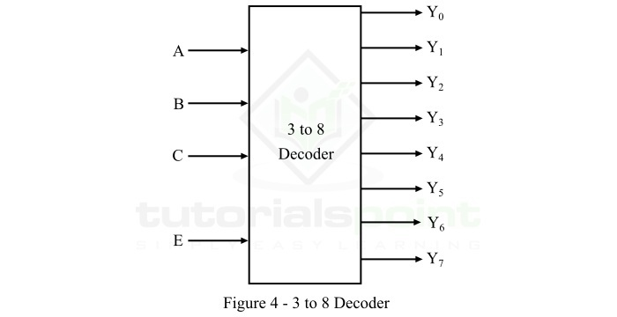
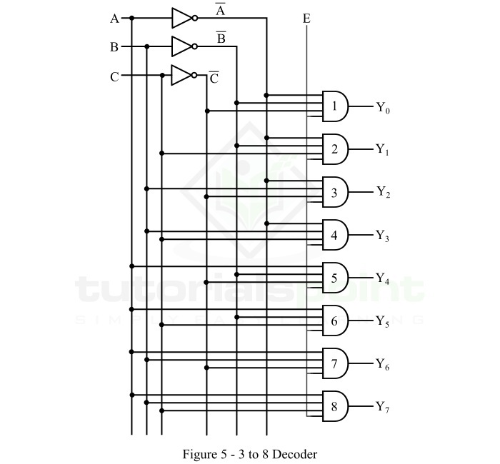

7. Result
The 3×8 Decoder was successfully designed and simulated in SimulIDE using AND and NOT gates. The observed outputs matched the expected results.
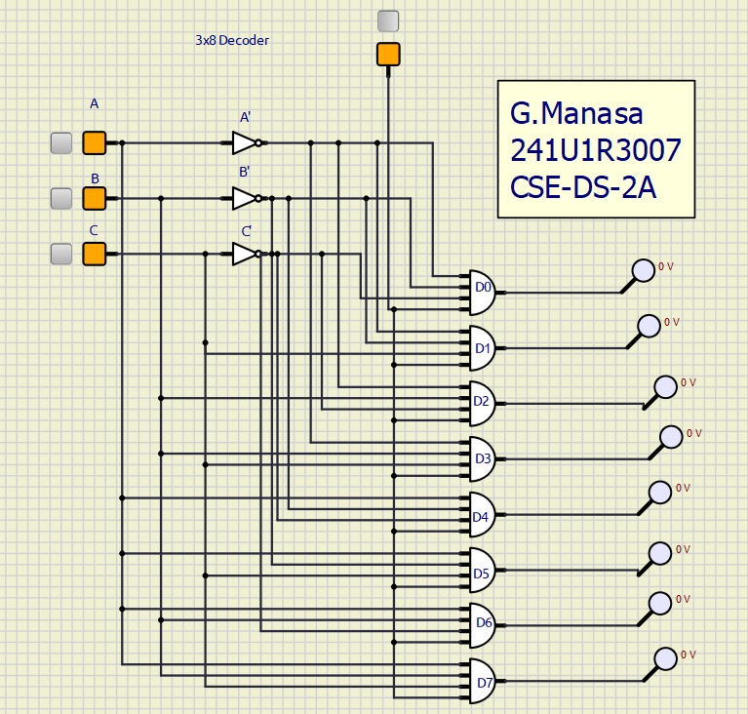

__Danke__

